**Task 1**

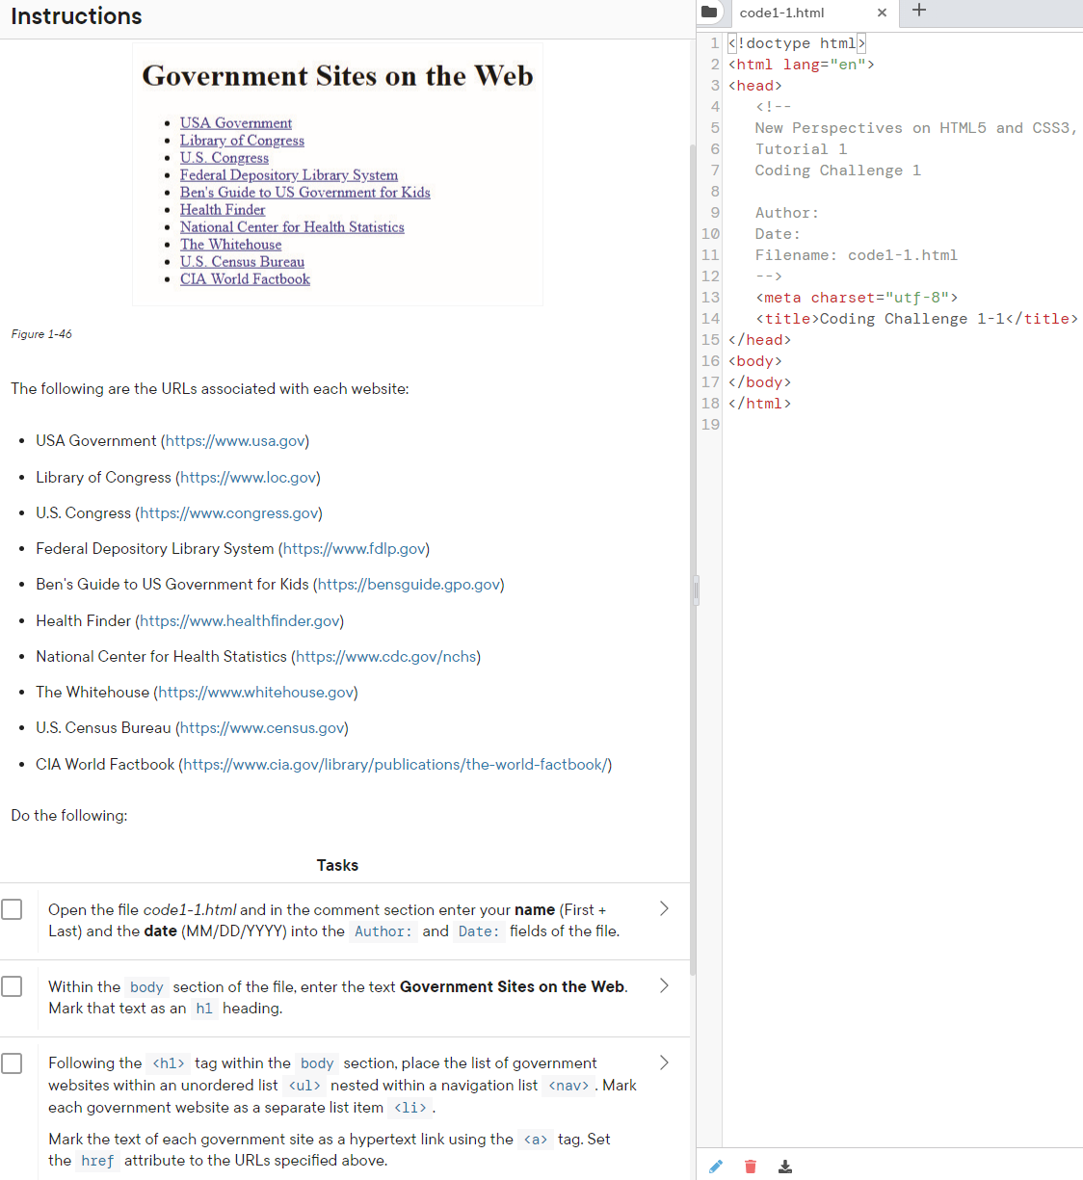

1. Use the code base on the right to create Figure 1-46. Delete the comments shown and instead place your name and the date as a comment.
2. Within the body tag you should create the title with an h1 tag and use an unordered list with anchor tags to create the Figure.

**Task 2**

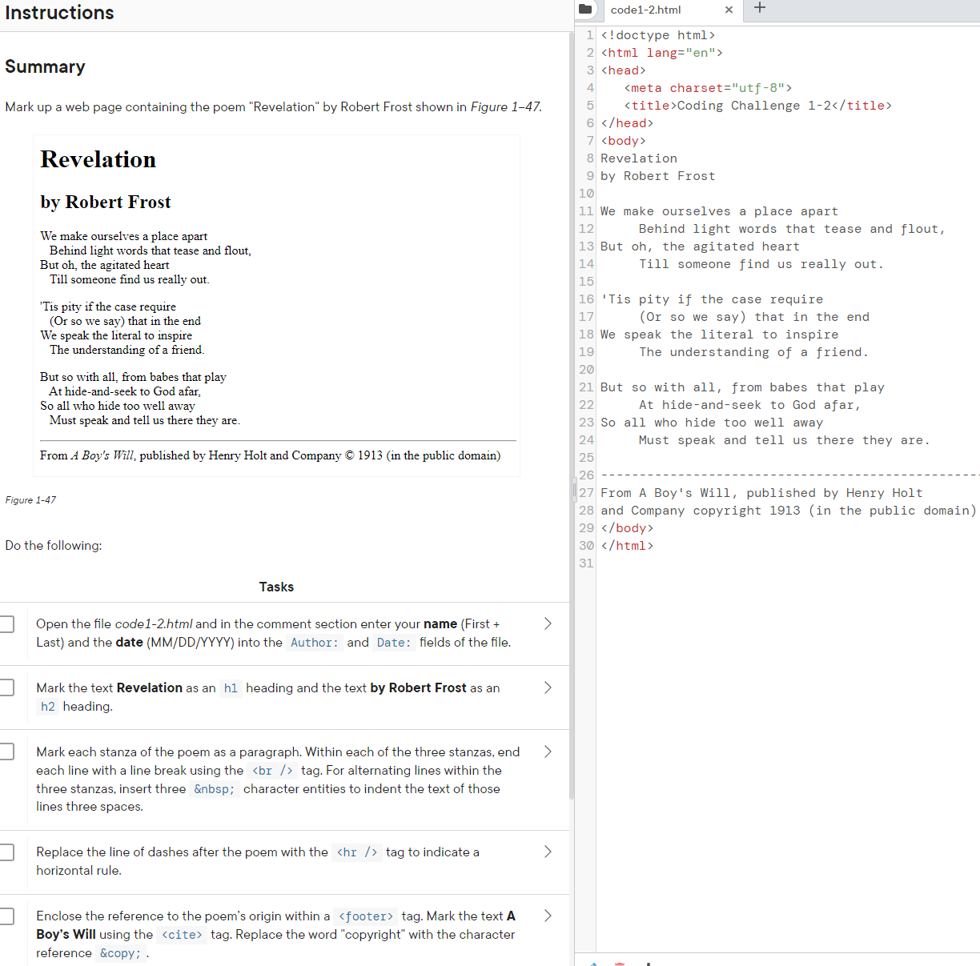

1. Use the code, as given below, to create Figure 1-47. Your name should be placed in a meta tag as well.
2. The header should be in an h1 tag and the poem’s author in an h2 tag.
3. Separate paragraphs with a p and end each line with a stanzas with a br/ tag. Use the &nbsp for the indentation. Replace the dashed line at the end with a hr/ tag.
4. Enclsoe the reference to the poem’s origin with a footer. Mark the test ‘A Boy’s Will using cite and replace copyright with &copy.

<!doctype html>

<html lang="en">

<head>

   <meta charset="utf-8">

   <title>Coding Challenge 1-2</title>

</head>

<body>

Revelation

by Robert Frost

We make ourselves a place apart

     Behind light words that tease and flout,

But oh, the agitated heart

     Till someone find us really out.

'Tis pity if the case require

     (Or so we say) that in the end

We speak the literal to inspire

     The understanding of a friend.

But so with all, from babes that play

     At hide-and-seek to God afar,

So all who hide too well away

     Must speak and tell us there they are.

-------------------------------------------------------------------

From A Boy's Will, published by Henry Holt

and Company copyright 1913 (in the public domain)

</body>

</html>

**External CSS**

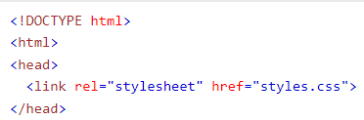

**Internal CSS**

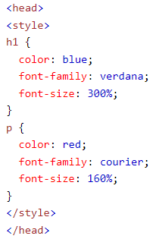

**Meta Tags**

Information about the data. Goes inside the head element. Not displayed on the page

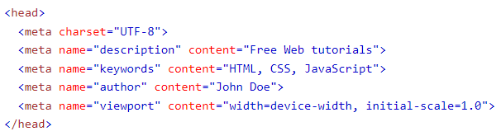

**Img Tags**

The <img> tag is used to embed an image in an HTML page. Images are not technically inserted into a web page; images are linked to web pages. The <img> tag creates a holding space for the referenced image. The <img> tag has two required attributes:

* src - Specifies the path to the image
* alt - Specifies an alternate text for the image, if the image for some reason cannot be displayed



**Task 3**

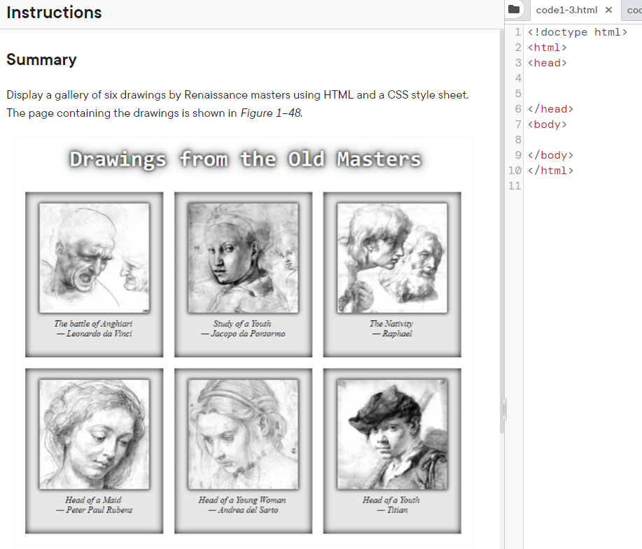

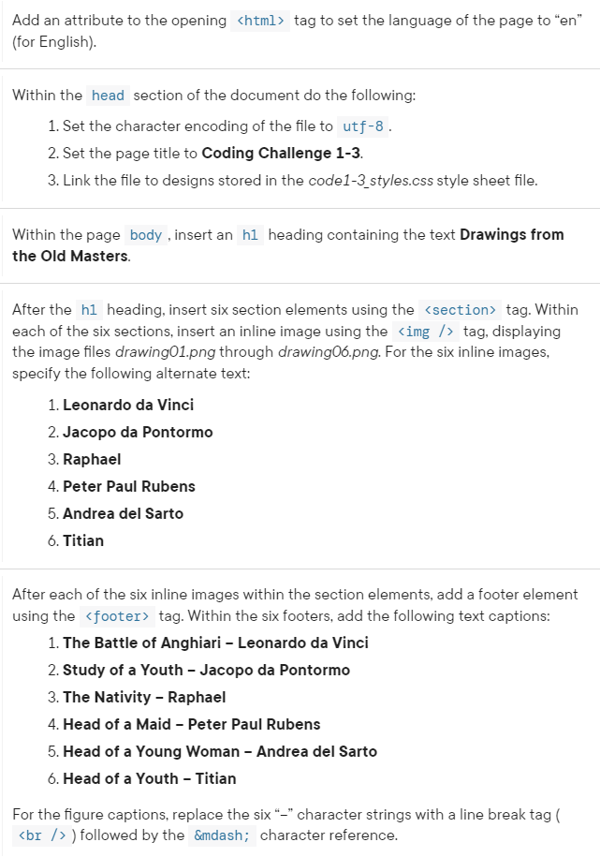

your name

provided css files for Task 3.